For each question from 16 to 20, choose the word(s) closest in meaning to the underlined word(s).  
Shade your answer (1, 2, 3 or 4) on the Optical Answer Sheet.

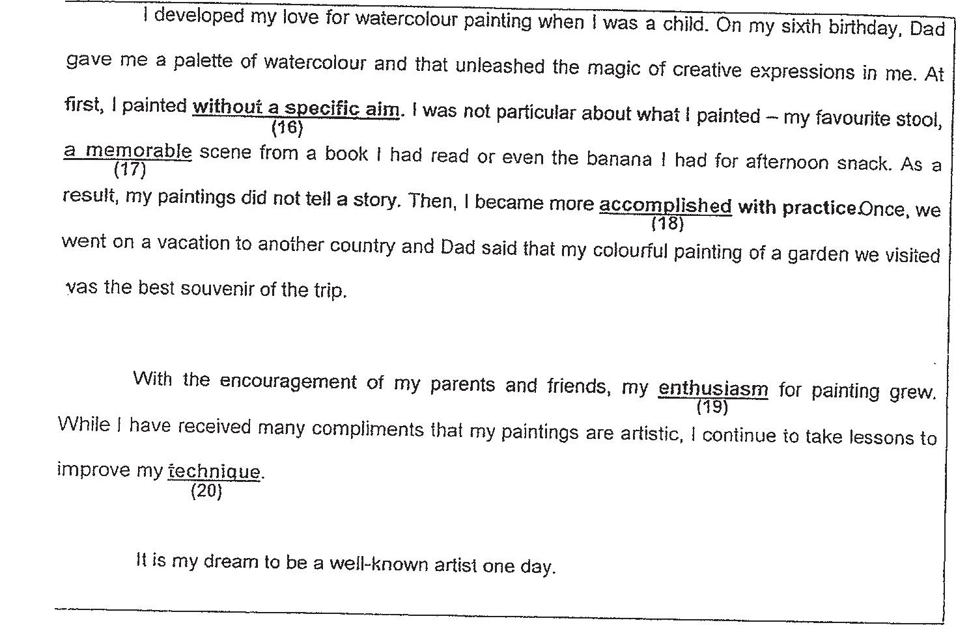

| Vas tne best souvenir of the trip.





76 (1) curiously  
(2) randomly  
(3) recklessly  
(4) relentlessly

Tf (4) an undeniable  
(2) an irremovable  
(3) an unbelievable  
(4) an unforgeitable

43d (1) adepi  
(2) perfect  
(3) correct  
(4) accurate

